**POS-Plugin Management**

Following are the steps to be followed in sequence to manage the entire process for configuring the POS Plugin:

Step #A: Configuring Plug-in Manager in Ginesys HO user interface

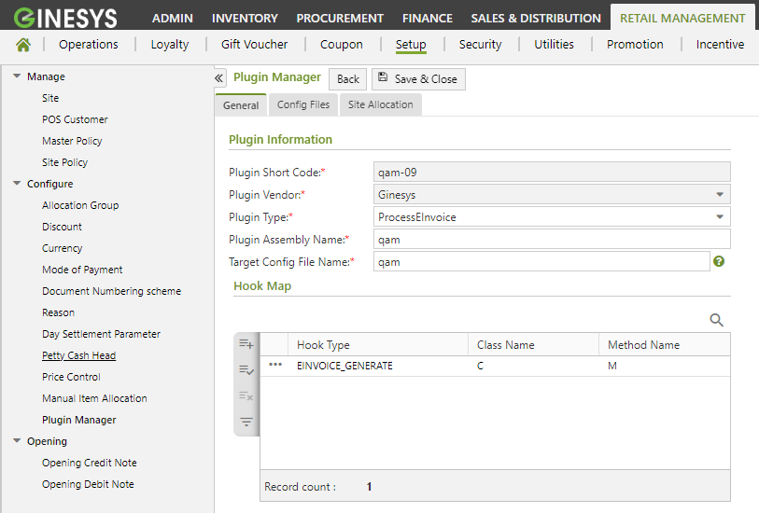

Step #B: RFID (Radio-Frequency IDentification) configuration in Ginesys HO user interface

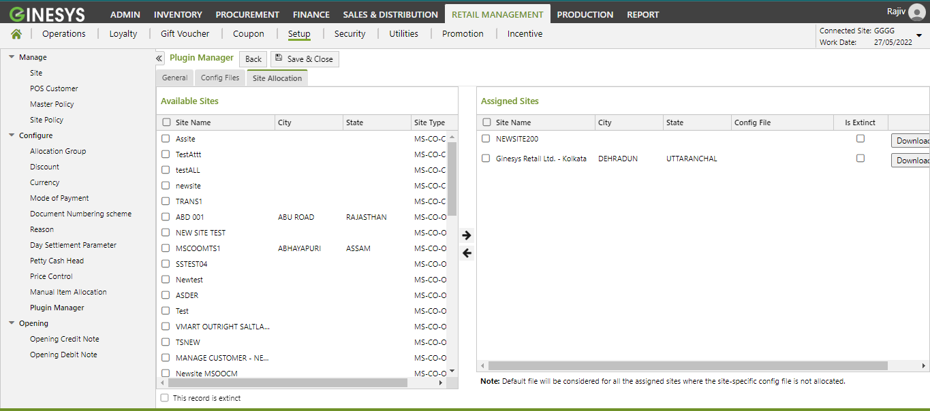

Step #C: Data Synchronization based on site from HO to POS

Step #D: Update the latest POS Plugin using the AutoUpdater

Step #E: Pulling/syncing down the required configuration from HO via Data Exchange in the POS system

Step #F: Logout and login into the POS application

Step #G: Test whether RFID is being called from POS after each bill save

**Scope/Requirement Statement of the third party DLL.**

The DLL file is a template for handling RFID events generated from Ginesys POS systems.

RFID integration patterns with Ginesys POS are of following types

1. Single SKU scanning with RFID scanner through regular barcode scanning option in Ginesys POS, In this case though barcodes are read in bulk by the RFID scanner, they are added one by one through the regular barcode scanning window in Ginesys POS. The barcodes are scanned one after the other and the cashier does not get to review the barcodes being scanned.

2. Multiple SKU scanning with RFID scanner through bulk barcode scanning option in Ginesys POS, In this case barcodes are scanned by the RFID scanner and are populated in a bulk scanning window of Ginesys POS. In this mode, the cashier gets a chance to review the scanned barcodes, check the quantities and verify if all were scanned properly.

3. Any one of the above options can also be integrated with anti-theft alarm systems installed in POS stores where the "checked-out" RFIDs can be detected by the alarm system and allow them to pass without firing the alarm. This way of RFID integration removes the need for using additional EAS tags and Sensormatic gates. Instead, RFID scanning gates are used to allow checked out RFID tags and fire alarms for not checked-out tags.